# **Name: Abdurrahman Qureshi**

# **Roll No: 210451**

Practical No: 17

**1) Develop a program to extend ‘dog’ from ‘animal’ to override ‘move()’ method using super keyword**

**CODE:**

class Animal {

void move() {

System.out.println("Animal moves."); }}

class Dog extends Animal {

void move() {

super.move();

System.out.println("Dog moves."); }}

class EXP17Dog {

public static void main(String[] args) {

Animal animal = new Animal();

animal.move();

Dog dog = new Dog();

dog.move();}}

**OUTPUT:**

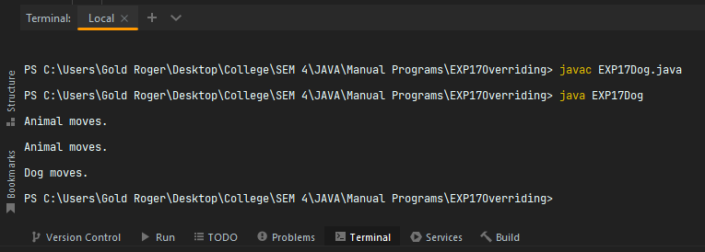

**2) Develop a program to extend ‘square’ from ‘rectangle’’. Override the ‘area()’ method to demonstrate the concept of overriding.**

**CODE:**

class Rectangle {

protected double length;

protected double width;

public Rectangle(double length, double width) {

this.length = length;

this.width = width; }

public double area() {

return length * width; }}

class Square extends Rectangle {

public Square(double side) {

super(side, side); }

public double area() {

return length * length; }}

class EXP17RectangleArea {

public static void main(String[] args) {

Rectangle rectangle = new Rectangle(5, 10);

System.out.println("Rectangle Area: " + rectangle.area());

Square square = new Square(7);

System.out.println("Square Area: " + square.area());}}

**OUTPUT:**

